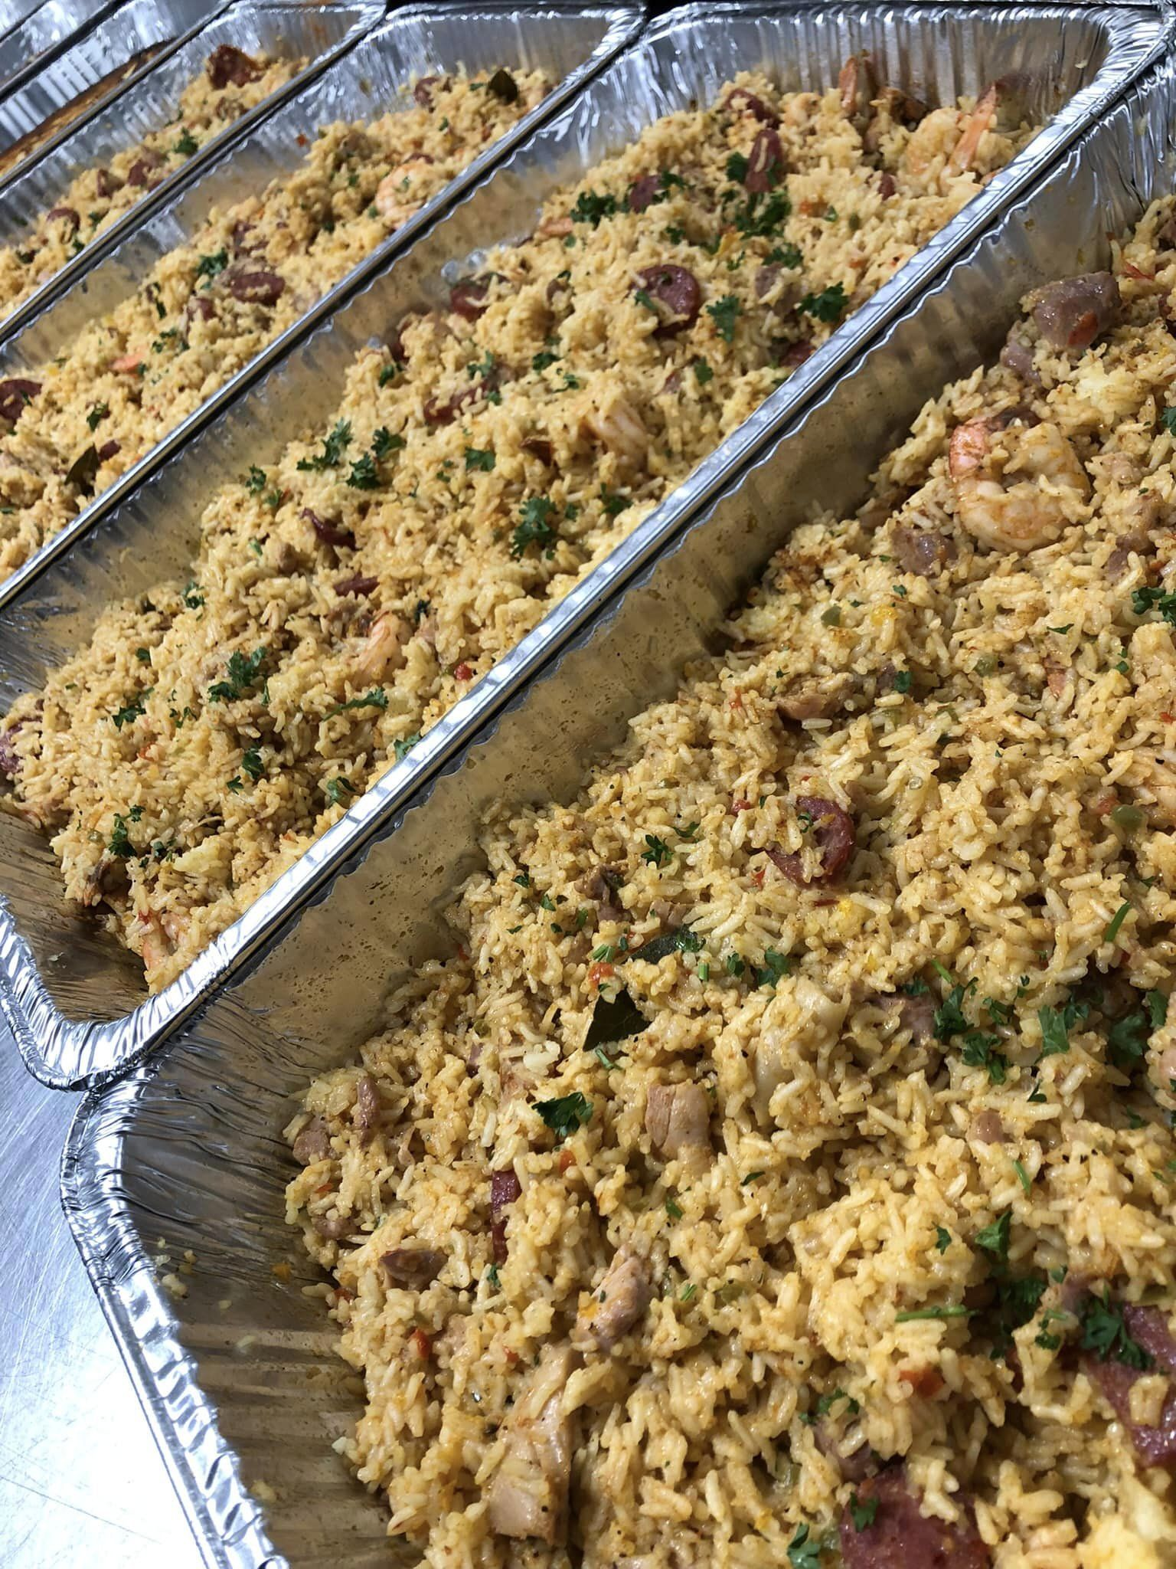Social Events Catering

Menu

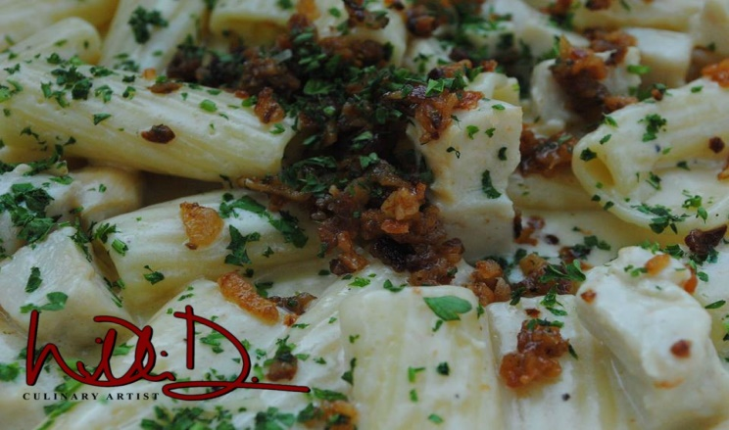

Setup and Delivery:

$35 Setup + Delivery ***(varies based on location)***

Drop-Off/ Self-Serv Buffet Service

**Disposable Warming Equip**: $12 per setup needed + Delivery

**Stainless/Porcelain Equip**: $30 per station + $100 Equipment Deposit (Refundable)

Assisted Buffet Service

Disposable: $12 per setup needed +$30 per hour per assistant + Travel

Stainless/Porcelain: $30 per station + $30 per hour per assistant + Travel

Appetizers

**Chicken Drumsticks w/ Chipotle Aioli $5.25ppa**

*Chicken Drumsticks, Frenched, Brined, Coated in Panko and fried until golden brown. Served with Chipotle Aioli.*

**Jerk Chicken Skewers $4.75ppa**

*Chicken Breast cut into cubes and placed in a traditional Scotch Bonnet Jerk Marinade. Grilled and served alongside a Jerk Aioli.*

**100% All Beef Meatballs $2.95ppa**

*80/20 Beef Chuck. Fresh Spices. Panko. Parmesan Cheese. BBQ or Sweet and Spicy Chili.*

**Spicy Crab Beignets $5.5ppa**

*Lump Crab combined with peppers, spices, fresh herbs and a light batter. Fried until golden brown. Served with Creole Remoulade for dipping.*

**Nashville Hot Chicken Biscuit $4.25ppa**

*Buttermilk Marinated Chicken Tenderloin. Deep Fried until crispy and flaky. Tossed in scratch-made Nashville Hot Oil. Topped with Remoulade and served on our award winning buttermilk biscuits.*

**Sausage and Pepper Trio $3ppa**

*A trio of smoked sausage, Italian sausage and spicy sausage combined with peppers and onions. Very delicious, a great way to start* *any meal.*

**Braised Beef Sliders $4.75ppa**

*Beef Chuck Marinated and slow cooked until extremely tender. Braised in fresh herbs, spices and its own juices. Pulled apart, this is* *served atop a mini bun and served with BBQ Sauce and caramelized onions .*

**Shrimp, Spinach and Artichoke Blackened Shrimp Puff Pastry $3.5ppa**

*Creamy Parmesan Spinach, Artichoke and Blackened Shrimp nestled into puff pastry and baked to a golden brown.*

**Elotes. Street Corn (Veg) $4.5ppa**

*Sweet Yellow Corn, Chile, Cotija Cheese and Mayo. Garnished with Fresh Cilantro.*

**Veggie Dumplings (Veg) $3.25ppa**

*Eggplant, Squash, Fresh Garlic, Green Onion, Ginger and minced cabbage. Cooked down with fresh herbs, spices and wrapped into gyoza wrappers. Seared and steamed until tender. Served with Sesame Ginger Sauce for dipping.*

**Salmon Slider $5.50ppa**

*Freshly ground Atlantic Salmon. Fresh Garlic, Lemongrass, Brioche and a Peppercorn Harissa Aioli. Served on Brioche.*

**Cajun Shrimp Bruschetta $4.25 ppa**

*Fresh Roma Tomato, Roasted Red Bell Pepper, Fresh Basil, Fresh Mozzarella and Ground Peppercorn Served alongside toasted Ciabatta Crostinis.*

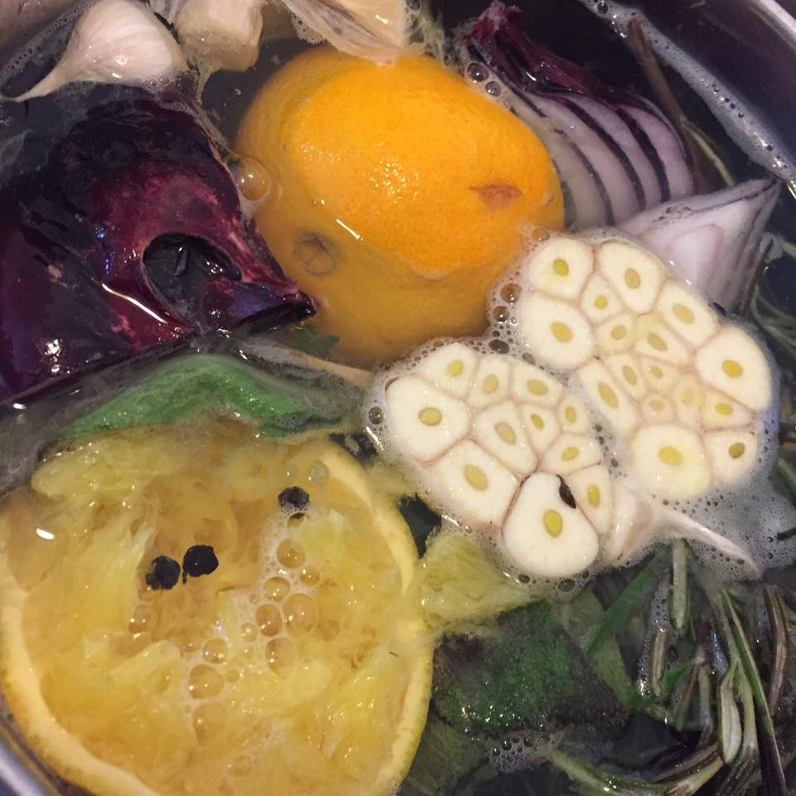

Entrée Proteins

**\*Fried Chicken Pieces. Brined $4.95pp. Wings ONLY. $5.95pp**

*Chicken Pieces brined in a combination of fresh herbs and spices. Fried until golden brown and delicious.*

**Jai’s Jerk Chicken $5.75pp**

*Chicken Pieces Marinated in our in-house marinade. Broiled or grilled and served with Scotch Bonnet Pepper Sauce.*

**\*LHG Broiled Chicken Pieces (GF) $5.50pp**

*Hand Butchered Chicken Pieces brined overnight. Tossed in Olive Oil, Fresh Lemon Zest, Fresh Herbs, Fresh Garlic and broiled until delicious and fall off the bone.*

**Airline Cut Tuscan Chicken $8.5pp**

*Hand Butchered Airline Cut Chicken Breasts. Brined and Prepared with a Creamy Tuscan Sauce. Basil. Sun-dried Tomato. Cream. Chicken Stock.*

**Jambalaya $7ppa**

*A combination of andouille sausage, chicken thighs, shrimp and fresh herbs and spices make this one a favorite for any crowd.*

**Butterflied Jumbo Lemon Garlic Shrimp $8.5pp**

*Jumbo Shrimp Butterflied in fresh lemon and garlic until done. Garnished w/ Parsley*

**Fried Catfish Fillet w/ Cajun Remoulade $7pp**

*Catfish coated in a Cajun buttermilk marinade, dredged and fried to a golden brown. Served with a Cajun Remoulade.*

**Momo’s Oven Roasted Salmon (GF) $8pp**

*4-6 oz. Marinated and Slow Roasted. Topped with a Cajun Lemon Garlic Butter. Tender and Flavorful! Lemon Honey Peppercorn Available for +$1pp.*

**Fried Honey Chipotle Garlic Shrimp $7.5pp**

*Light and Crispy Shrimp Tossed in our Honey Chipotle Garlic Sauce*

**\*Crab Cakes $9pp (Mini $7pp)**

*Lump and Claw Crab meat harmoniously mixed with just the right amount of spice, minced peppers,* *onions, herbs and Panko breadcrumbs.*

**Grilled Lamb Chops $57 per rack**

*Rack of Lamb Massaged in a Roasted Garlic Oil, Fresh Thyme, Fresh Rosemary, Fresh Garlic, Sea Salt and Cracked Black Pepper.*

**Beef Pot Roast** **$7.25ppa 14pp**

*Beef Roast marinated and seared to lock in flavor. Braised for a few hours with mirepoix until tender and falling apart.* *Served with reduced pan Jus.*

**Braised Beef Lasagna $8.25ppa 16pp**

*Layers of lasagna pasta, red sauce and braised beef topped with fresh mozzarella and baked throughout. Garnished with fresh parsley*

**Marinated Skirt Steak w/ Chimichurri $12.5ppa 24pp**

*Skirt Steak Marinated and Grilled Over Open Fire. Slightly Charred. Served with scratch-made chimichurri.*

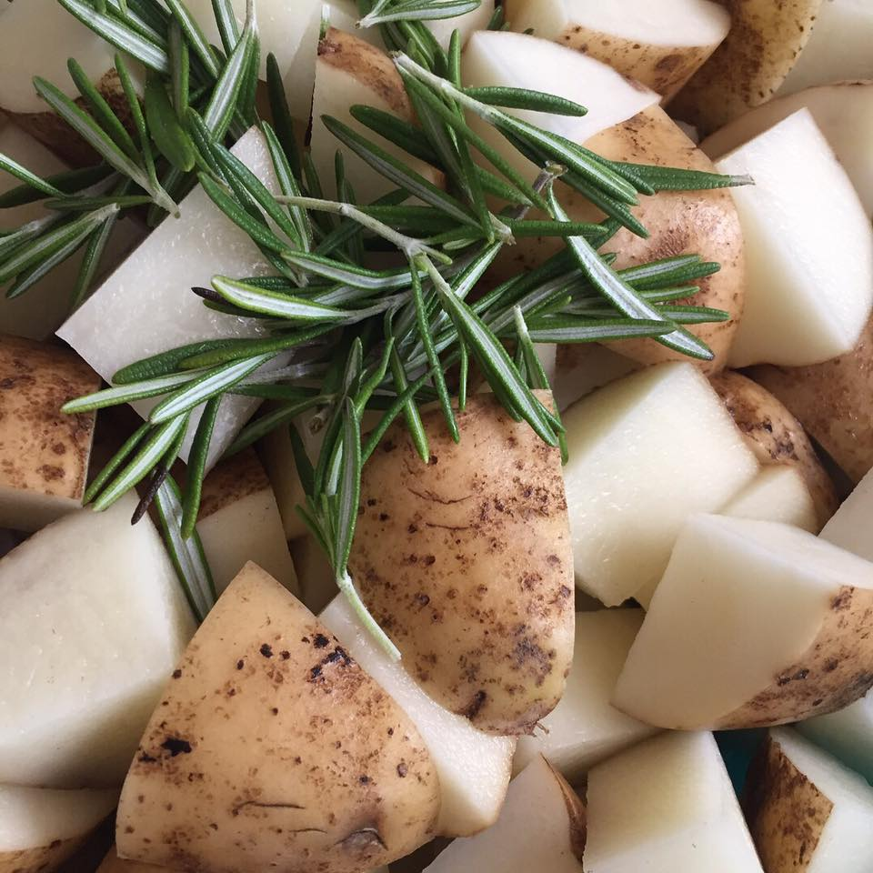

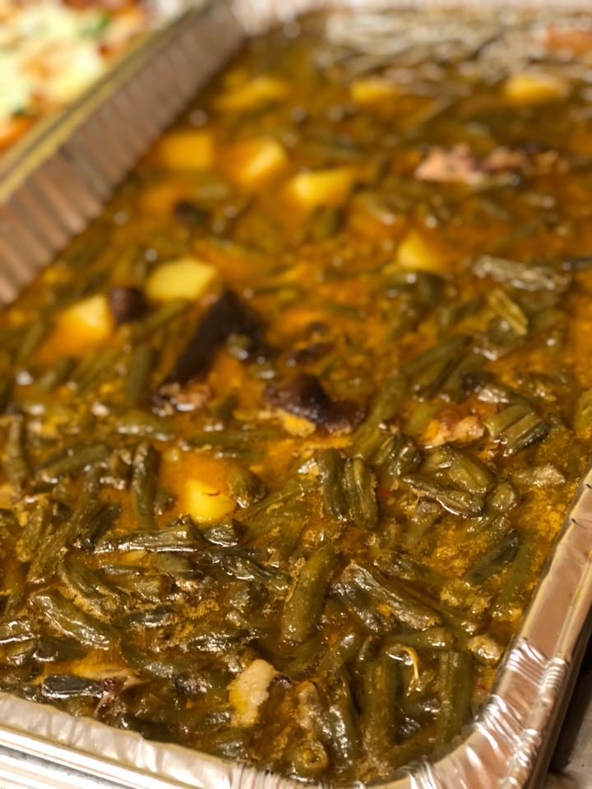

Sides

**Red Oak Salad (Vegan) $4pp**

*Red Leaf Lettuce. Cherry Tomatoes. Slivered Red Onions. Pinwheel Cucumbers. Feta Cheese and Honey Vinaigrette.*

**Classic Pasta Salad $3.75pp**

*Tri-Color Rotini pasta tossed together with an Italian Vinaigrette, Pepperoni, Parmesan cheeses and Spices! Very Delicious!*

**\*Collard Greens $4pp**

*Fresh Collards. Cooked down with Smoked Turkey Tails in our secret broth for hours. Combined with fresh peppers, onions and garlic. This item will always be a hit with guests.*

**Stewed Green Beans $3.75pp**

*Green Beans simmered down with smoked turkey and Idaho potatoes. Simple, yet tasty and a favorite of many*

**Garlic Broccoli (Veg)(GF) $3.75pp**

*Fresh Broccoli Florets tossed in house made Garlic Butter. Broccollini available for +$1.5pp.*

**Seasonal Vegetables (Vegan) $3pp**

*Chef’s Choice seasonal vegetables drizzled in garlic pepper oil, sea salt and cracked black pepper.*

**Buttermilk Cornbread $3pp**

*Cornbread made with love and Buttermilk.*

**Crispy Potato Salad (Veg) $3pp**

*Idaho Potatoes steamed and fried to a golden crisp. Tossed in our Lemon Dill Aioli and garnished w/ Chives.*

**Roasted Yukon Gold Potatoes $3.50pp**

*Buttery Rich Yukon Gold Potatoes coated in Fresh Herbs and a hint of Truffle Oil. Baked until Golden and Delicious.*

**Parmesan Mashed Potatoes (Veg) $4.25pp**

*Yukon Gold Potatoes steamed until creamy and tender. Paired with cream, roasted garlic and parmesan cheeses and whipped until light and fluffy!*

**\*Jay Marie’s Baked Mac N’ Cheese (Veg) $4.75pp**

*Elbow Macaroni Pasta until al dente and lathered in house made 3-cheese sauce. Finished with a garlic butter panko topping ad toasted* *until golden brown with a slight crisp.*

**Cal’s Candied Yams (Veg) $2.5pp**

*Sweet Potatoes layered in a spice blend of cinnamon, nutmeg and allspice. Sweetened with brown sugar and a bit of vanilla. Ask about our Roasted Sweet Potatoes (+$2pp)!*

**Rum & Butter Sweet Plantains $4.5ppa**

*Sweet Plantains cooked down in whole fat butter and oil until tender and just right. Finished with Rum Butter Sauce.*

**Jan’s Fluffy Buttered Rice $2.45pp**

*A combination of Long Grain and Jasmine Rice. Cooked to perfection and tossed with sea salt and butter.*

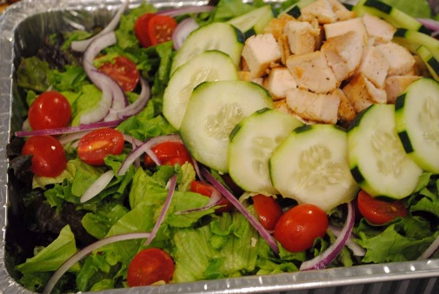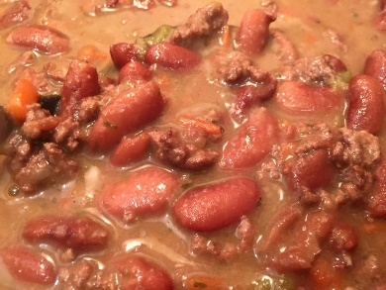

**Fruit Display (Veg)**

**Small $45** *(15-20 ppl)*  **Lrg $75** (20-30ppl)

*Seasonal Fruits arranged in an eye-catching display. Arrangements vary.*

**Salad Buffet (Veg)$8.50pp**

*A variety of salad greens, vegetables, meats, cheeses, and dressings! A very good way to start any meal.*

**Charcuterie Planks $16pp**

*An intricate assortment of artisanal breads/crackers, smoked/cured meats, dried fruits and pickled vegetables arranged on platters* *and served to awaiting guests.*

